Clinic Supplies
GST/PST applicable to all Clinic Supplies Purchases

 | Item # | Description | Price/Each
 | 302 | BioOrigin Fractionated Coconut Oil 1 Gal | 134.95
 | 302A | BioOrigin Fractionated Coconut Oil 250ml Refill-Bottle & Lid is extra | 9.50
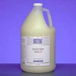 | 321 | Biotone Advance Therapy Gel 1 gallon  Spreading effortlessly over the skin, this seed-oil-based gel has one of the lightest, most pleasant textures you’ll find. Offers significantly more coverage than typical oils so you use much less yet assures continuous workability that doesn’t require the interruption of reapplication. An ideal choice for those who want the lightest of oil textures. Water-dispersible. Leaves no greasy residue. Hypoallergenic. | 117.00
 | 395 | BioOrigin Therapure Body Cream 1 Gal | 94.99
 | 395A | BioOrigin Therapure Body Cream 250 ml Refill -Bottle & Lid Is extra | 6.50
 | 309 | Biotone Advanced Therapy Gel-250ml  Bottle refill – Bottle & Lid is extra | 8.95
 | 323 | Biotone Clear Results Oil 1 gallon  Clear Results light, silky formula washes out easily from fabrics, leaving your sheets and towels looking their best. In fact, recent comparison studies show Clear Results washed out more clearly and completely than any other oil tested. Contains Jojoba Oil and Aloe. | 136.95
 | 306 | Empty Oil Bottle 250ml | 1.00
 | 306A | Lids For Oil Bottles | .50
 | 322 | Pump for one gallon bottle | 17.95
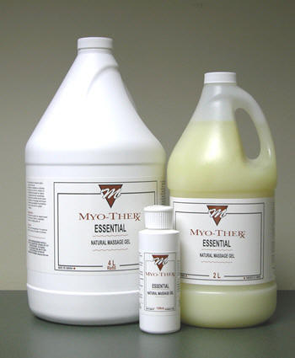 | 382 | Myo-Ther Essential Gel 4L | 109.95
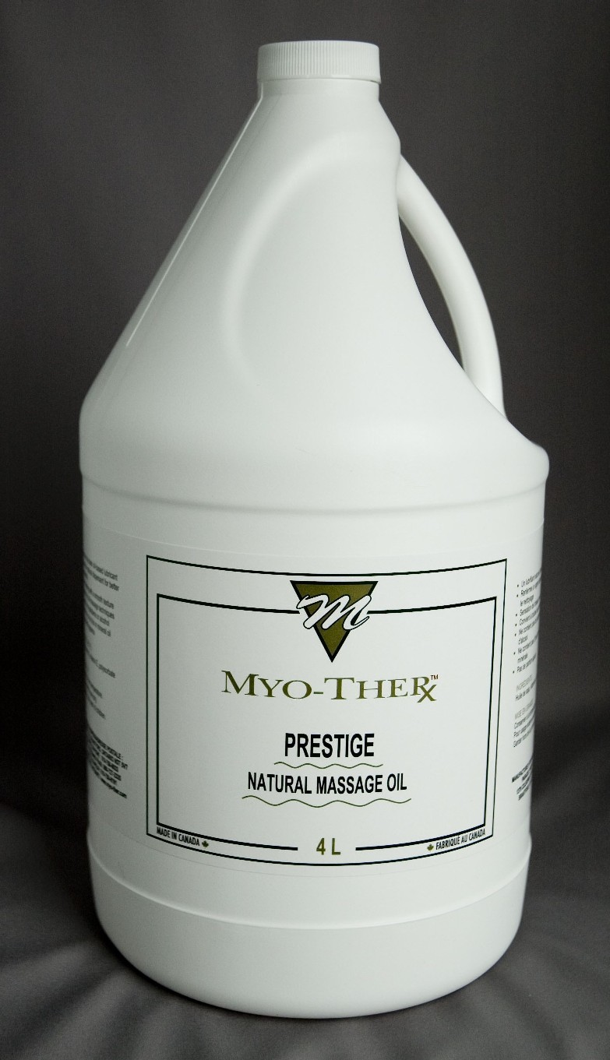 | 383 | Myo-Ther Prestige Oil 4L | 97.95
 | 454 | Myo-Ther Complete Lotion | 83.95
 | 465 | Myo-Ther Signature Lotion 4L | 81.95
 | 290 | Twill Flat Sheet – Heavy 58”x 85” Color 65/35 poly/cotton | 18.75
 | 291 | Twill Flat Sheet - Heavy 58”x 85” White | 18.75
 | 333 | Paraffin Wax/100 grams | 1.08
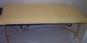 | 332 | Fleece Table Pad  Our Fleece Table Pad is soft on the skin and washes very well. | 39.95
 | 355 | Fleece Crescent Cover | 15.00
 | 360 | Gel Pack Hot/Cold 6” x 10” Blue  These hot/cold gel packs are an essential item for any professional practice. Not only are they functional in a clinical environment, they are also a perfect retail item for your clients. | 8.00
 | 455 | Thermophore 14 X 14 MaxHeat | 115.00
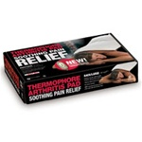 | 370 | Thermophore 14”x 27” MaxHeat  Intense moist heat with the added convenience of a  3-level switch, so hands are free to continue activities during therapy. Specially blended cover is washable | 140.00
 | 375 | Thermophore 14” x 14” Standard | 89.99
 | 391 | Thermophore 14” x 27” Standard | 119.00
 | 378 | Disposable Towel Face Rest Covers Fitted  (Box of 50) | 27.95
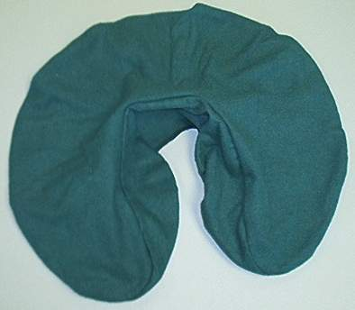 | 390 | Flannel face cradle cover – fitted color | 8.95
 | 392 | P3 Cream 237 ml  All-natural Muscle & Joint Pain-Relieving Cream. | 24.00
 | 393 | P3 Cream 500ml. | 36.00
 | 458 | PIP Allergy Free-Probiotic Spray 200 ml | 23.95
 | 464 | Cloth Mask with OVCMT Logo | 5.95

GST/PST applicable

 | Item # | Description | Price/Each
 | 500 | Green Cando tubing /Per foot | 1.00
 | 501 | Green Latex Free CanDo Band /Per foot | 1.25
 | 510 | Red Latex Free CanDo Band/Per foot | 1.25
 | 511 | Yellow Latex Free CanDo Band/Per foot | 1.25
 | 504 | Vinyl Covered Anti Bacterial Pillow 9” x 12” | 9.95
 | 505 | Epsomgel tube 90ml | 19.45
 | 506 | Epsomgel with pump 240ml | 37.95
 | 509 | Epsomgel with pump 500ml | 64.95
 | 507 | Pillow 20”X 26” Staphcheck | 19.95
 | 508 | Pillow Protector-Standard Poly/Vinyl | 9.95
 | 671 | Deluxe Digital Table Warmer | 232.00

Clothing with OVCMT Logo
GST/PST applicable to all Clothing Purchases

 | Item # | Description | Price/Each
 | 650 | Yoga Shirt – Black | 24.95
 | 651 | Yoga Shirt – Grey | 24.95
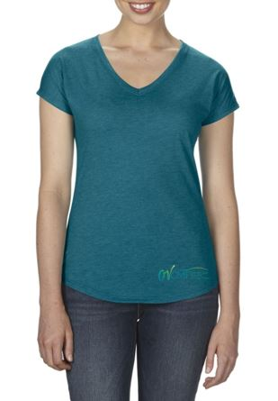 | 652 | V Neck Triblend – Galapogos Blue | 18.50
 | 653 | V Neck Triblend – Slate | 18.50
 | 669 | V Neck Triblend – Black | 18.50
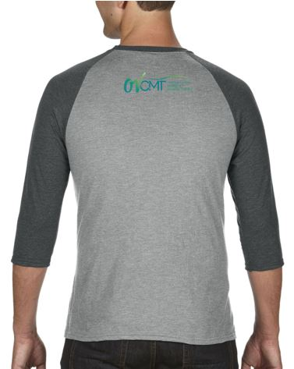 | 654 | ¾” Sleeve Shirt – Assorted Colors | 22.00
 | 655 | Tee/Crew Neck - Graphite | 17.50
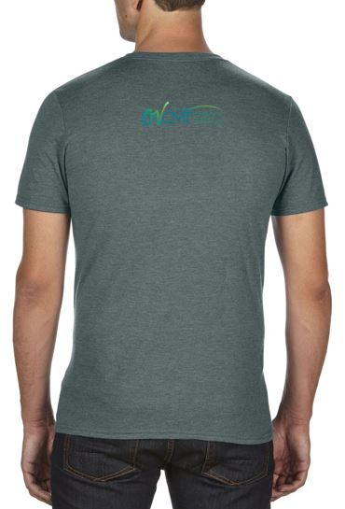 | 656 | Tee/Crew Neck – Galapogos Blue | 17.50
 | 657 | Tee/Crew Neck – Dark Grey | 17.50
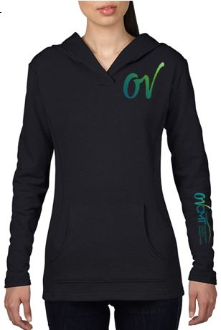 | 658 | Hoodie - Pullover – Black | 45.00
 | 659 | Hoodie – Pullover – Dark Grey | 45.00
 | 660 | Unisex Hoodie – Black | 59.00
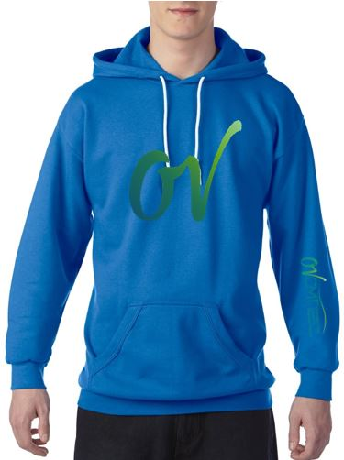 | 661 | Unisex Hoodie – Royal Blue | 59.00
 | 662 | Unisex Hoodie – Charcoal | 59.00
 | 672 | Unisex Hoodie – Light Grey | 59.00
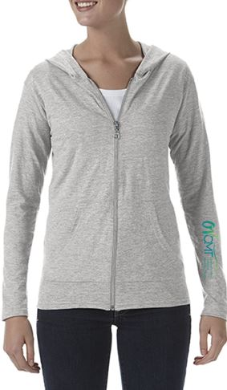 | 663 | Woman’s Zip Hoodie – Light Grey | 31.50
 | 664 | Woman’s Zip Hoodie – Dark Grey | 31.50
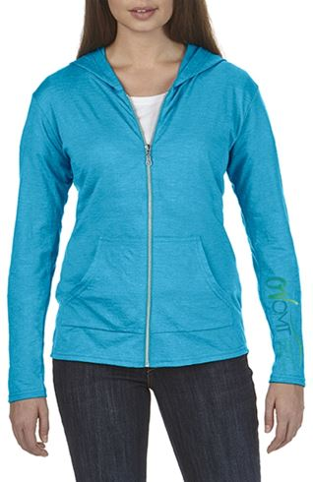 | 665 | Woman’s Zip Hoodie – Galapogos Blue | 31.50
 | 666 | Ball Cap – White/Grey | 20.00
 | 667 | Ball Cap – Black Mesh | 18.50
 | 668 | Ball Cap – Grey Flat Brim | 28.00
 | 670 | Lanyard | 2.00
 | 673 | Unisex Full Zip Hoodie – Black | 42.95
 | 674 | Unisex Full Zip Hoodie – Royal Blue | 42.95
 | 675 | Unisex Full Zip Hoodie – Grey | 42.95
 | 676 | Unisex Pullover Hoodie - Sapphire | 37.95
 | 677 | Unisex Pullover Hoodie - Black | 37.95
 | 678 | Unisex Pullover Hoodie - Royal Blue | 37.95
 | 679 | Unisex Pullover Hoodie - Grey | 37.95

Textbooks
(GST Only 5%) applicable to all Textbook Purchases

 | Item # | Description | Price/Each
 | 133 | Fitch-Talking Bodies, Listening Hands  (2nd Edition) | 129.95
 | 136 | Massage Therapy-ProHealthsys (3rd Edition) | 99.00
 | 137 | Orthopedic Conditions-ProHealthsys | 70.00
 | 149 | Orthopedic Assessment, 7th edition | 59.95
 | 150 | Anatomy Workbook | 25.95
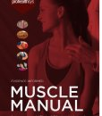 | 278 | Muscle Manual-5th Edition | 70.00

Misc Items
GST/PST applicable

 | Item # | Description | Price/Each
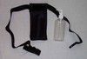 | 301 | Oil Holster | 15.00

 | Item # | Description | Price/Each
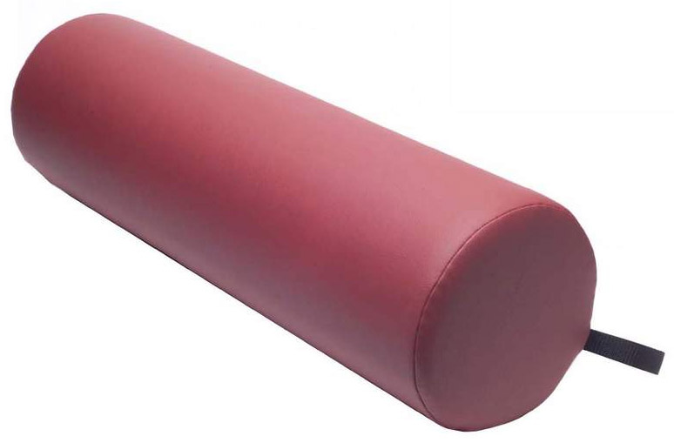 | 904 | Bolster 6” X 26” Round (black or mystic blue) | 62.00
 | 908 | Wheeled Cart for carrying massage table | 97.50
 | 909 | Massage Table Side Extensions with Velcro | 79.00

Store Refund/Return Policy

OV Therapy Supply stands behind
the quality of the products it sells
and guarantees your satisfaction!

No Cash Refunds

Customers may return unused items for full refund within 14 days after purchase. The original sales receipt must be submitted. Items must be returned in their original undamaged packaging. Clothing items must have original tags still attached and be unworn. Textbooks are not returnable unless defective.

Within 14 days of purchase, in the event that an item is defective, we reserve the right to replace the item, refer to the manufacturer’s warranty or refund the purchase price as shown on the original sales receipt.

